Making Your Own Advent Wreath

Materials:

- Oasis
- Dessert plates
- Candles (3 purple, 1 pink, 1 white)
- Tape (not included; masking tape preferred)
- Greens (not included)
- Clippers or scissors (not included)

“Where do I get greens?”
- Trim some from your own yard or ask a neighbor!
- Trim some from public areas along your daily walk!
- Visit Christmas Tree sale stands for discarded or dropped greens!
- Visit the garden section of Lowes or Home Depot! Ask if you can have some dropped or discarded branches.

Wreath Making Instructions:
- Place your brick of oasis onto the colored dessert plate. Position as flatly and evenly as possible on the plate.
- Using 4 pieces of tape in a tic-tac-toe board-like pattern, secure the oasis to the plate. See image below for guidance.

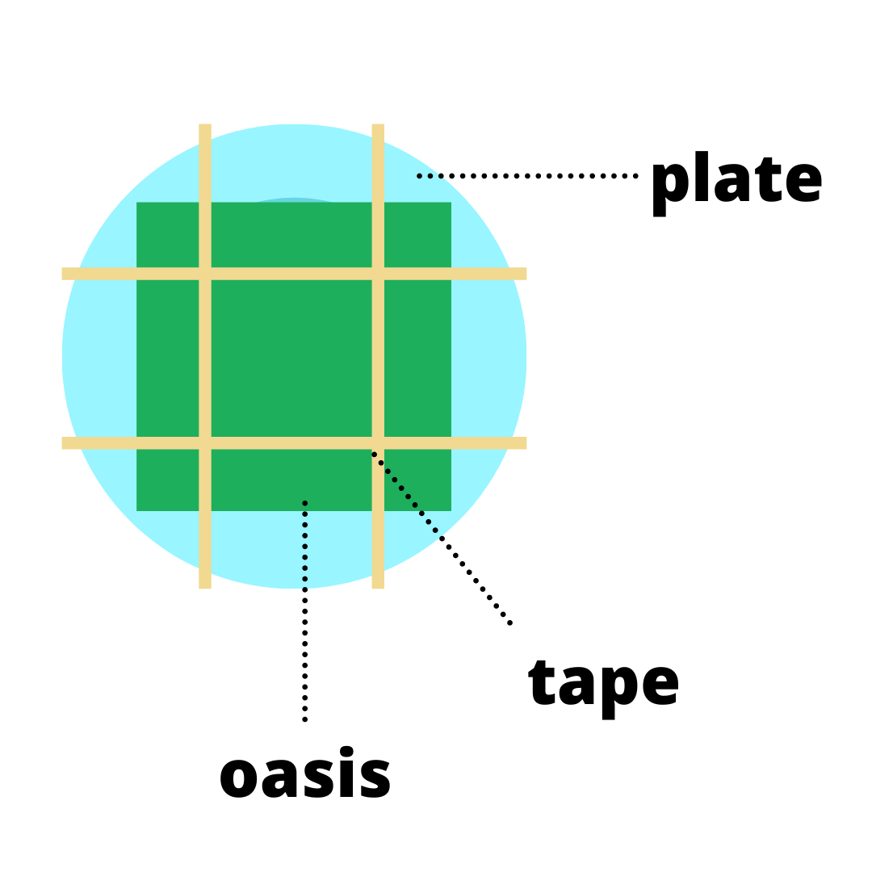

- Wet the oasis. Pro Tip: Plug your sink, and fill the sink with 1 inch of water. Tip your oasis plate upside down and place on the surface of the water for 5 seconds. Lift your plate out of the water and turn right side up. The water will pool to the bottom of the oasis.
- Stick your candles into the wet oasis: purple and pink at the corners, and white in the center. Stick them far enough in to make sure they’re sturdy; keep in mind you will be adding greens and want to keep the flame as far from the greens as possible. See the image below for guidance.

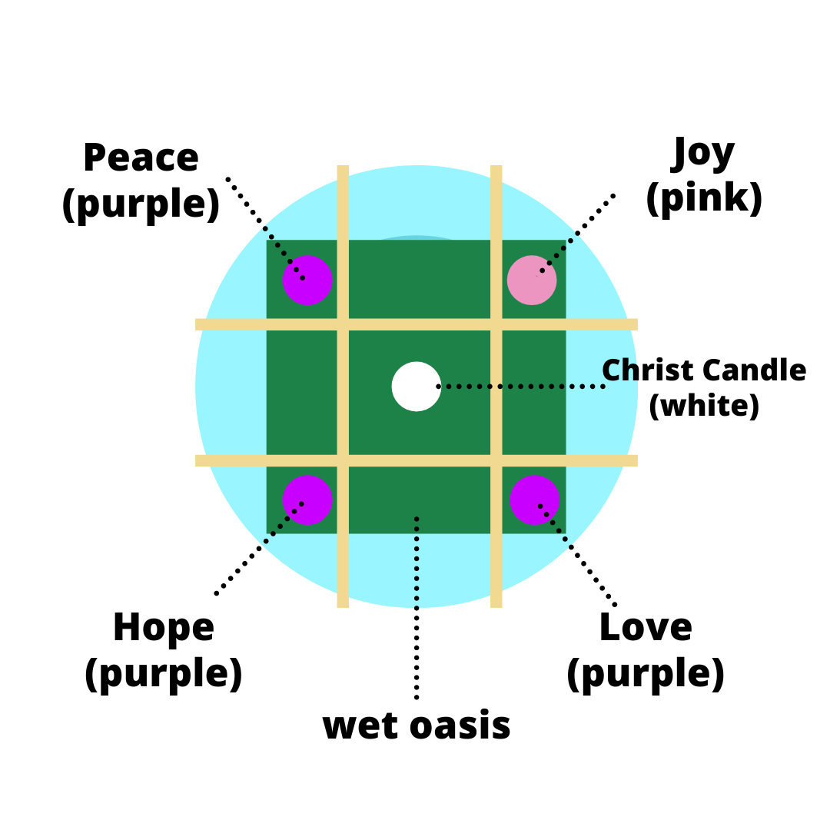

- Begin sticking your greens into the wet oasis, building from the bottom to the top. Have your scissors or clippers handy for easy trimming as needed. Pro Tip: Shorter greens nearer to your candles will limit the possibility of a fire hazard.
- Get creative! Further adorn your wreath with other decorations to your taste. Suggestions: small Christmas ornaments, pine cones, ribbons, festive picks, etc.
- To keep your wreath greens as fresh as possible, water your wreath once a week. Pro Tip: Hold your wreath under the sink faucet turned on low for 3-5 seconds. Note the amount of pooling on the dessert plate to keep it from damaging your display surface.

